**Teacher Preparation Notes for**

**“****How does evolution result in similarities and differences?”** [1]

In this hands-on, minds-on activity, students analyze the similarities and differences between bat and squirrel skeletons and between bat and insect wings. Students learn about the two ways that evolution produces similarities: (1) inheritance from shared evolutionary ancestors (homologous characteristics) and (2) independent evolution of similar characteristics to accomplish the same function (analogous characteristics). In the laboratory investigation, students observe the external anatomy and locomotion of earthworms, mealworms, and crickets. Students use these observations and the concepts they have learned to figure out which two of these animals are more closely related evolutionarily.

Before your students begin this activity, they should be familiar with natural selection. For this purpose, I recommend either the analysis and discussion activity, “What is natural selection?” (<https://serendipstudio.org/exchange/bioactivities/NaturalSelectionIntro>) or the hands-on activity, “Evolution by Natural Selection” (<https://serendipstudio.org/sci_edu/waldron/#evolution>).

If your lab period is 40-50 minutes long, I recommend that you complete class discussion of questions 1-11 before the lab period, so you will have enough time for the laboratory investigation.

**Learning Goals**

In accord with the Next Generation Science Standards[2]:

* Students prepare for the Performance Expectation MS-LS4-2. “Apply scientific ideas to construct an explanation for the anatomical similarities and differences among modern organisms … to infer evolutionary relationships.”
* Students learn the Disciplinary Core Idea, LS4.A. “Anatomical similarities and differences between various organisms living today …, enable the reconstruction of evolutionary history and the inference of lines of evolutionary descent.”
* Students engage in the Scientific Practices:
  + “Analyze and interpret data to determine similarities and differences in findings.”
  + “Apply scientific ideas, principles, and/or evidence to construct an explanation for real-world phenomena, examples, or events.”
* This activity provides the opportunity to discuss the Crosscutting Concept, “Patterns can be used to identify cause and effect relationships.”

Additional Content Learning Goals

Students will understand:

* the distinction between similarities due to inheritance from shared evolutionary ancestors (homologous characteristics) and similarities due to independent evolution of similar characteristics to accomplish the same function (analogous characteristics)
* the relationship between form and function.

**Equipment and Supplies for each 6-9 students in your largest class:**

– display containers:

* 2 medium sized plastic containers (volume ~2-4 cups)
* 1 gallon-sized plastic bag (Ziploc or with tie)
* 2 plastic trays or plates

– 5 live mealworms (larvae of *Tenebrio molliter*)

– 5 live crickets (e.g., Acheta domestica)

– 5 live earthworms (e.g., *Lumbricus terrestris*)(You may find it easier to purchase the smaller red wigglers, *Eisenia fetida*. Larger earthworms can be purchased at <https://www.chewy.com/joshs-frogs-canadian/dp/928350>.)

These animals can be purchased from a local pet store (e.g., Petco) or online. You can reuse the animals all day but, depending on how many classes you teach, you may want to buy replicate sets to ensure freshness and mobility for each class.

If you will not be using the animals right away, make sure they are stored in containers with holes punched in the lids or screens on top to allow gas exchange. Instructions for care of the animals can be found in the following sources:

* earthworms – <https://www.earthwormworks.com/caring-for-your-worms.html>
* mealworms – <https://www.flinnsci.com/api/library/Download/87e4d66b70df4826992dfd252d78e14d>
* crickets – <https://cpb-us-e1.wpmucdn.com/blogs.cornell.edu/dist/3/1009/files/2015/05/Crickets-Eat-CIBT.pdf>

– paper towels (at least 2)

– magnifying glasses or hand lenses (2-4)

Optional:

– 2 dissecting microscopes

– 2 rulers

– 1 or 2 gloves for each student (If you don’t provide gloves, make sure that the students wash their hands after handling the animals.)

**For each 6-9 students, set up 3 stations.**

1. Place 5 mealworms in one of the display containers.
2. Place 5 earthworms on a damp paper towel in one of the display containers and cover them with a damp paper towel so they stay moist and active.
3. Crickets are best viewed in a sealed plastic bag that has been expanded to full volume (either the bag they come in from the pet store or a 1-gallon plastic storage bag with a few crickets). However, you cannot keep the crickets in a sealed bag overnight and must store them in a different covered container with a screen on top or holes in the lid. Be careful the crickets don’t jump away during transfer.

For each station 1 and station 2, have 1 or 2 hand lens or magnifying glasses available and possibly a ruler and/or a dissecting microscope.

**Instructional Suggestions and Biology Background**

To maximize student participation and learning, I suggest that you have your students work individually or in pairs to complete each group of related questions and then have a class discussion after each group of questions. In each discussion, you can probe student thinking and help them develop a sound understanding of the concepts and information covered before moving on to the next group of related questions.

A key is available upon request to Ingrid Waldron ([iwaldron@upenn.edu](mailto:iwaldron@upenn.edu)). The following paragraphs provide additional instructional suggestions and background information – some for inclusion in your class discussions and some to provide you with relevant background that may be useful for your understanding and/or for responding to student questions.

The driving question for this activity is “What are the evolutionary processes that result in the similarities and differences?” You may want to begin by asking your students “What do you already know about how evolution produces similarities and differences?”

Evolution of Similarities and Differences in Mammals and Insects

Squirrels are familiar to most students, and a squirrel skeleton shows enough resemblance to a human skeleton for most students to readily identify many of the bones. Question 1 asks for general common names of bones, not precise anatomical names. The figure below may aid the interpretation of the bat skeleton shown in question 2. Both squirrels and bats are in the class Mammalia, but squirrels are in the order Rodentia and bats are in the order Chiroptera.[3]

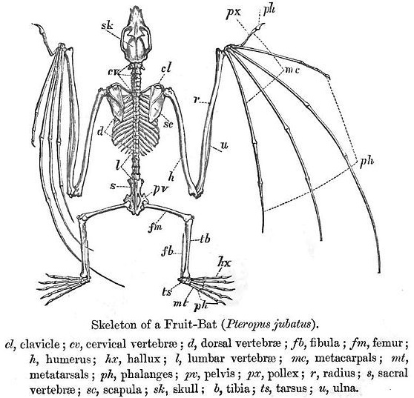

The thumb appears at the top and the pinky is the finger that is closest to the body. (<https://i.pinimg.com/originals/7b/c4/26/7bc4266af247a5af2917c7e97258c1ff.jpg>)

For question 3b, students may not know that squirrels use their tails for balance as they move high up in the trees (<https://www.ncbi.nlm.nih.gov/pmc/articles/PMC8427179/pdf/icab023.pdf>). (Squirrels also use their tails for communication.)

To answer question 4, students should propose that natural selection favored mutations that lengthened the finger bones that supported the wings. The fossil record provides little insight about intermediate stages in the development of bat flight, but the main hypothesis is that wing precursors initially evolved for gliding, followed by muscle attachments that allowed steering, and finally wings that the animal could flap to produce powered flight.[4] [5] Question 4 provides the opportunity to discuss how natural selection results in “form matches function”.

In addition to the characteristics of mammals listed on the top of page 2 of the Student Handout, mammals also have three middle ear bones and fur or hair made of the protein keratin.

|  |  |
| --- | --- |
| The main components of bones are a mineral, hydroxyapatite (Ca10(PO4)6(OH)2), and the protein, collagen. In contrast, insect exoskeletons are made of proteins and the polysaccharide, chitin (see figure). The thicker parts of an exoskeleton provide support, protection, and points of attachment for the insect’s muscles. At the joints, the exoskeleton is thinner and flexible. The exoskeleton is relatively impermeable to water, so it prevents insects from drying out. | Monomer of Chitin  Although chitin contains nitrogen it does not contain amino acids. (<https://en.wikipedia.org/wiki/Chitin>) |

|  |  |
| --- | --- |
| If your students are not familiar with molting, you may want to show them the very brief time lapse movie of a cicada molting out of its exoskeleton available at <https://en.wikipedia.org/wiki/Arthropod_exoskeleton>. Good descriptions of the process of molting are available at <https://www.thoughtco.com/how-insects-grow-1968346> and <https://genent.cals.ncsu.edu/bug-bytes/morphogenesis/>.  The tough exoskeleton does not stretch as the insect grows. Therefore, an insect has to shed its old exoskeleton in order to get bigger. First, it grows a new soft exoskeleton under the tough old exoskeleton. Then, the insect splits open the old exoskeleton, emerges from it, and sucks in air to expand the new exoskeleton before it becomes too tough to stretch. | An exoskeleton that a cicada has shed (<https://www.sciencelearn.org.nz/resources/2842-insects-physical-characteristics>) |

Insects have three pairs of jointed legs. A few immature insects (e.g., caterpillars) have additional pairs of prolegs, which are not true legs because they have no joints.

|  |  |
| --- | --- |
| The primary functions of insect antennae are sensing odor molecules in the air and sensing mechanical stimuli.  Mammals, other vertebrates, earthworms, etc. have a closed circulatory system, which means that, throughout the circulatory system, the blood is contained in blood vessels or the heart. In contrast, insects, other arthropods, etc. have an open circulatory system (see figure on right). The flow of the hemolymph is too sluggish and inefficient to provide gas exchange at the level needed to sustain the high metabolism of flight. Instead, a system of tubes supplies oxygen and removes carbon dioxide. (See figure below.) | Circulatory, Immune, Reproductive And Respiratory Systems, 47% OFF  (<https://createcirculatorysystems.weebly.com/uploads/5/6/7/6/56760383/8407714_orig.jpg>) |

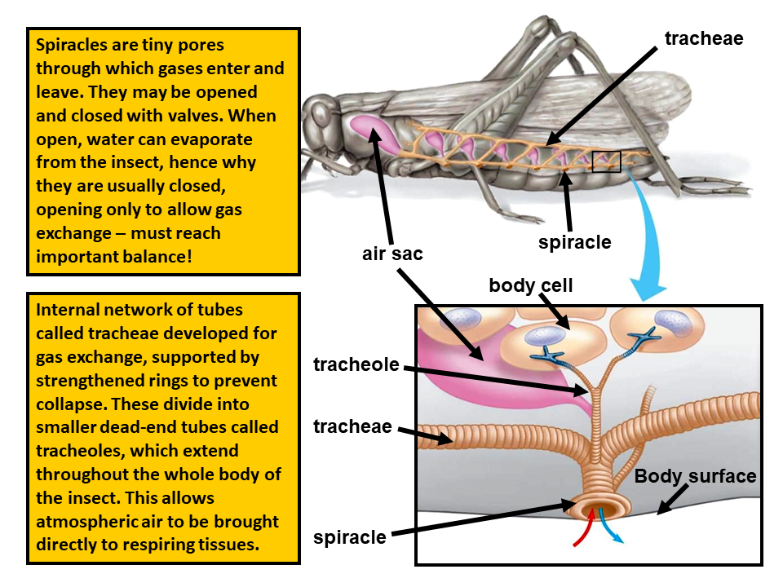

(<https://d1e4pidl3fu268.cloudfront.net/b8234201-f6c0-4934-9ada-b909ce01d6c2/cover.png>)

As discussed in questions 6 and 7, insects and bats are descended from different evolutionary ancestors that had very different types of skeletons. In these evolutionarily distant groups, natural selection had very different raw materials to shape into wings. This explains why insect and bat wings are made of very different components.

|  |  |
| --- | --- |
| This figure shows a cross-section of a small part of an insect wing, with a thin “wing membrane” and the thicker supporting “vein”. Both are made of exoskeleton (labeled as “cuticle”) and epidermis. Hemolymph circulates in the “blood space” in the veins. Gas exchange is supported by the tracheae in the veins. In summary, the veins in the wings allow the circulation of gases and hemolymph, and the veins support the wings. In addition, cracks can develop in the thin “wing membrane” (due to the stresses of flight), and veins prevent cracks from spreading. | (<https://en.wikipedia.org/wiki/Insect_wing>) |
| This figure shows a mammalian bone. Bat wings are supported by bones that are thinner and lighter than most mammalian bones. Since flight depends on generating enough lift to counteract an animal’s weight, natural selection has favored lighter weight in flying animals. Also, a lot of energy is required to flap the wings to power flight, so it is advantageous for the wings to be thin and weigh less. (Red bone marrow contains blood stem cells that can become red blood cells, white blood cells, or platelets. Yellow bone marrow is mostly fat.) | Anatomy of the bone; drawing shows spongy bone, red marrow, and yellow marrow. A cross section of the bone shows compact bone and blood vessels in the bone marrow. Also shown are red blood cells, white blood cells, platelets, and a blood stem cell.  (<https://www.ncbi.nlm.nih.gov/books/NBK66050.1/figure/CDR0000258005__182/?report=objectonly>) |

|  |  |
| --- | --- |
| Homologous structures are observed in evolutionarily related species and have been inherited from a common evolutionary ancestor. This figure shows the homologous bones of the forelimbs of tetrapods, including mammals, amphibians, reptiles and birds. This is part of the evidence that all tetrapods share an | (<http://ircamera.as.arizona.edu/NatSci102/NatSci/images/convergent.htm>) |

evolutionary ancestor with similar forelimb bones.[6] Although the same bones are present in most tetrapod forelimbs, the shapes and proportions are quite different to serve different functions in different animals. This nicely illustrates Darwin’s famous evolutionary “descent with modification”.

Analogous structures share the same function, but they had separate evolutionary origins. Natural selection produced similar structures to accomplish the same function. For example, insect wings and bat wings have a similar thin and long, wide structure, as a result of natural selection to accomplish flight. (This type of independent evolution of similar characteristics is called convergent evolution.) Analogous structures typically have different component parts. For example, bat wings are made up mainly of skin, bones and muscles, whereas insect wings are made up mainly of exoskeleton.

The top of page 4 in the Student Handout gives some important clues for distinguishing homologous vs. analogous characteristics. These clues illustrate the Crosscutting Concept, “Patterns can be used to identify cause and effect relationships” (in this case, evolutionary cause and effect). For example, multiple detailed similarities suggest inheritance from a shared evolutionary ancestor as the cause of these similarities.

Laboratory Investigation

In the laboratory investigation of earthworms, mealworms and crickets, students combine observation of the external structure and behavior of these three animals with the concepts they learned in the earlier pages to figure out which two of these animals are more closely related evolutionarily. Question 12 asks students for their initial opinion. If there is disagreement you may want students to discuss their reasons for their differing opinions, but please do not explain the correct answer until after students have answered question 23.

The figure below shows many details of earthworm anatomy. The parts that are most relevant for this activity are the circular and longitudinal muscles in the body wall, the segments which can each change shape, and the setae (bristles). Each segment is filled with non-compressible fluid so the volume of the segment is constant; this means that when the circular muscles contract the segment gets narrower and longer and when the longitudinal muscles contract the segment gets shorter and fatter.

|  |
| --- |
| https://www.sas.upenn.edu/~rlenet/EarthwormAnatomy1.jpg  (<https://www.sas.upenn.edu/~rlenet/EarthwormAnatomy1.jpg>) |

Earthworms do not have the antennae or jointed legs observed in insects. Their scattered eyes are microscopic, so not visible to the naked eye. Your students may notice and inquire about the clitellum, which secretes material that makes a cocoon which surrounds the eggs and fertilizing sperm after copulation.

The slimy feel of the earthworm is due to mucus which keeps the body surface moist for gas exchange. The mucus also lubricates the earthworm as it moves through the soil.

When the circular muscles of a segment of the earthworm body are contracted, the segment gets skinnier and elongated. When the longitudinal muscles of a segment are contracted, the segment gets shorter and fatter, and the setae or bristles grip the ground. The figures below show how an earthworm moves, using:

* waves of alternating contractions of the circular and longitudinal muscles in the body wall of each segment,
* the hydrostatic skeleton provided by the fluid-filled segments, and
* the setae (bristles) that grip the surface under them, for the segments that have the longitudinal muscles contracted.

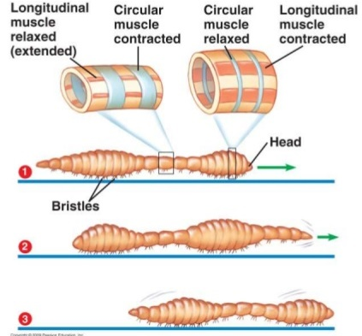

(<https://image.slidesharecdn.com/locomotionsupport1-141023095018-conversion-gate02/95/biology-form-5-chapter-2-locomotion-support-21-part-1-11-638.jpg?cb=1414057971>)

To understand how waves of alternating contractions of the circular and longitudinal muscles move the earthworm forward, compare the numbered segments in diagram 2 with the same segments in diagram 1. Notice how:

* contraction of the circular muscles in segments 1-3 elongated these segments which pushed the head forward
* the contractions of the longitudinal muscles in segments 4-7 shortened these segments which pulled the rest of the body forward.

(Adapted from <https://www.studyandscore.com/studymaterial-detail/earthworm-body-wall-coelom-locomotion-and-digestive-system>)

Videos that show earthworm locomotion include:

* “Earthworm (Lumbricus) Locomotion” <https://www.youtube.com/watch?v=0Texxu3p7I8>
* “Investigate how muscles in the body wall and small bristles enable earthworms to move through soil” (<https://www.britannica.com/video/22019/Locomotion-earthworm>)
* “Movement in Earthworms” <https://www.youtube.com/watch?v=Kq1QDMWXBNM>.

A 4.5-minute informative and amusing video about earthworms is “The Amazing World of Earthworms in the UK” (<https://www.youtube.com/watch?v=9ZHTerOJYMA>).

As shown in the figures below, mealworms have short legs and antennae and tiny eyes. Mealworms prefer a dry habitat, such as stored grain. They can extract the water they need from their food and from cellular respiration, which produces water from the metabolism of glucose.

|  |
| --- |
| https://mealwormmayhem.weebly.com/uploads/8/6/8/1/8681843/5935135_orig.png  (<https://mealwormmayhem.weebly.com/uploads/8/6/8/1/8681843/5935135_orig.png> + <https://fineartamerica.com/featured/mealworm-beetle-larva-matthias-lenke.html?product=pouch>) |

A video that shows many features of mealworms (including the antennae, three pairs of legs and locomotion) is “Mealworms (Ant Foods)” (<https://www.youtube.com/watch?v=g_ERb3M2FGg>). If you show this video before question 23, you will want to play this video with the sound turned off, so you don’t give away that mealworms are the juvenile form of Darkling beetles.

|  |  |
| --- | --- |
| In mealworms, as in other insects, gas exchange occurs in multiple tiny tubes called tracheae. The tracheae are guarded by spiracles which can open and close as needed for gas exchange vs. preserving body moisture. |  |

(<https://carbontime.bscs.org/sites/default/files/animals/worksheets_assessments/6.1_Other_Animals_Reading_Mealworms.pdf>)

|  |  |
| --- | --- |
| This figure shows the external anatomy of a female cricket. (The cerci are sensitive to air currents, including sound.)[7]  If you want to show a cricket walking, you can show “Slow Motion Movie from a Field Cricket” (<https://www.youtube.com/watch?v=qIQHmiwnQGk>). If you want to show a slow-motion video of how a cave cricket jumps, you can show “Phantom TE 2010 Cricket Jump” (<https://www.youtube.com/watch?v=Kn6s-BQpT-A>). | Diagram  Description automatically generated  (<https://cricketcare.org/anatomy/>) |

As discussed in question 21, the similar long narrow shape of earthworms and mealworms is not due to recent shared evolutionary ancestors, but rather represents convergent evolution to a form that is well-adapted to a burrowing lifestyle. Similarly, the small or microscopic eyes also represents an adaptation to the burrowing lifestyle.

Once your students have correctly identified the evolutionary relatedness of mealworms and crickets in response to question 23, you may want to show them the lifecycle of mealworms/darkling beetles (see the figure below and the 3-minute video, “The Unseen Incredibleness of Mealworms”, <https://www.youtube.com/watch?v=P4w2cuh-9h4>).[8] The larval stages (mealworms) are specialized for eating and growing, and the adult stage (beetle) is specialized for reproduction and dispersal.

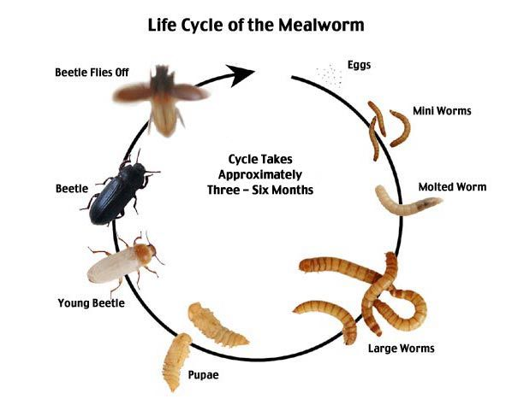

(<https://i.pinimg.com/originals/88/7a/8e/887a8e9f07542cb0d56a1cd900d40079.jpg>)

It may be helpful to know the classification of the animals included in this activity (see table below). Evolutionary relatedness is judged based on homologous characteristics that often are not obvious from the outside, so animals that have very different external appearance may be grouped in the same phylum (including larval forms such as mealworms and caterpillars which are grouped with other insects in the Arthropod phylum). In contrast, animals that look similar but have very different internal anatomy may be grouped in different phyla (e.g., different types of worms, including (1) mealworms, (2) earthworms and other segmented worms, (3) flatworms, and (4) roundworms).

|  |  |  |  |  |  |
| --- | --- | --- | --- | --- | --- |
| **Phylum** | **Subphylum** | **Class** | **Subclass** | **Order** | **Animal** |
| Annelids |  | Clitellates | Oligochaetes | Lumbriculida or Haplotaxida | Earthworms |
| Arthropods |  | Insects | Pterygota  (winged insects) | Orthoptera | Grasshoppers,  Crickets |
| Hymenoptera | Bees |
|  | Coleoptera | Mealworms → Darkling beetles |
| Chordates | Vertebrates | Mammals | Eutheria | Rodents | Squirrels |
| Chiroptera | Bats |

The figure below provides an overview of the phylogenetic tree of animals. Notice that exoskeletons and segmentation are not shown as key phylogenetic developments; this is because both exoskeletons and body segments appear to have evolved independently several times.[9]

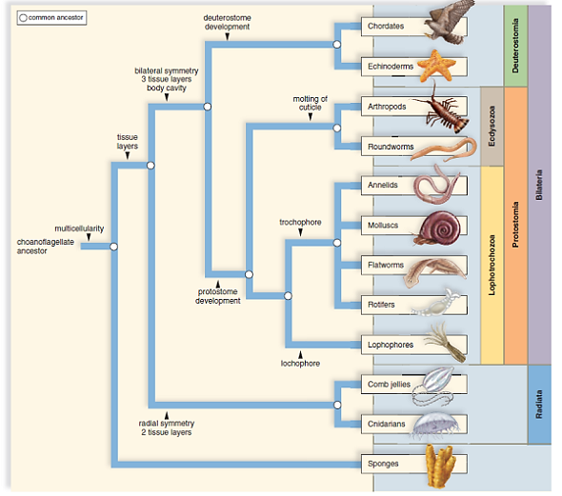

(<https://media.cheggcdn.com/study/91c/91c2a81c-71a2-4b9d-868e-9f613b174ff6/4849-28-1IRC1.png>)

**Related Activities**

Resources for Teaching and Learning about Evolution (<https://serendipstudio.org/exchange/bioactivities/evolrec>)

These Teacher Notes provide (1) suggestions for teaching evolution to students with religious concerns, (2) a review of major concepts and common misconceptions concerning natural selection, with recommended learning activities, (3) a review of major concepts and common misconceptions about species, descent with modification, and the evidence for evolution, with recommended learning activities, and (4) recommended general resources for teaching about evolution.

**Sources of Student Handout Figures**

* Squirrel Skeleton – <https://www.dkfindout.com/uk/animals-and-nature/rodents/inside-rodent/>
* Bat Skeleton – <http://www.allaboutbats.org.au/biology/>
* Grasshopper emerging from exoskeleton – <https://prairieecologist.com/2011/02/10/photo-of-the-week-february-10-2011/>
* Insects – <https://queenexpublishers.co.ke/wp-content/uploads/2021/05/insects.jpg>
* Insect Wing – <https://phys.org/news/2018-02-deadly-dragonfly-wings-bacteria.html>
* Bat Wing – <https://theneverlands.com/wp-content/uploads/2020/10/Bat-Hook-2.jpg>
* Earthworm – <https://res.cloudinary.com/dk-find-out/image/upload/q_80,w_1920,f_auto/DCTM_Penguin_UK_DK_AL645784_zcau0r.jpg>
* Mealworm – <https://www.allaboutfeed.net/wp-content/uploads/2020/12/001_640_IMG_AAF_26_WEB_DONdoesnotaffectmealworms_creditDreamstime.jpg>
* Cricket – <https://www.naturepl.com/cache/pcache2/01515333.jpg>

1. By Dr. Ingrid Waldron, Department of Biology, University of Pennsylvania, © 2024. These Teacher Preparation Notes and the related Student Handout, are available at <https://serendipstudio.org/exchange/bioactivities/EvolSimil>.
2. Next Generation Science Standards, available at <https://www.nextgenscience.org/get-know-standards>
3. There are roughly 30 orders and 6400 species of mammals. In comparison, there are roughly the same number of orders of insects, but over 1 million species.
4. Another evolutionary sequence of adaptive steps is analyzed in "How Eyes Evolved – Analyzing the Evidence" (<https://serendipstudio.org/exchange/bioactivities/evoleye>).
5. Students may inquire about flying squirrels, which are a group of squirrel species that are able to glide, using a furry skin membrane that stretches from wrist to ankle. They are not capable of flapping flight; flapping flight is observed in bats, insects and birds and gives these animals considerable additional capabilities.
6. Molecular similarities indicate that all living things (including bacteria, plants, and animals) had a shared evolutionary ancestor (<http://ircamera.as.arizona.edu/NatSci102/NatSci/images/convergent.htm>).
7. For a brief summary of additional information about crickets, see <http://www.enchantedlearning.com/subjects/insects/orthoptera/Cricket.shtml>.
8. You may want to contrast the type of development in mealworms/Darkling beetles (complete metamorphosis) vs. in crickets (incomplete metamorphosis). Complete metamorphosisis observed in insects where the larval stages look completely different from the adult (e.g. mealworms or caterpillars) and the transformation from the largest larva to the adult occurs in a pupa. Incomplete metamorphosis is observed in insects like crickets where the young resemble the adults, although they lack wings; each molt produces a larger insect with more nearly adult body proportions, and the final molt produces an insect with wings and mature reproductive organs.
9. All of the animals in this activity are bilaterally symmetric, an early evolutionary development. Bilaterally symmetric animals typically have a concentration of sensory organs at the head end, which allows the animal to gather information about the environment it is moving toward.